Below are the conference rooms and classrooms apart of the NDNU lease on campus. Please book all conference rooms or classrooms on Facilitron. If you are not set up in Facilitron please use the Event Request Form or work with your Departments EA to book a location. Please submit any facilities setup request not later than 2 weeks before your event. Please click below (Ctrl + Click) on the title of the location to be directly brought to the page you would like to visit.

Table of Contents
St. Mary’s 113 2
St. Mary’s 115 3
St. Mary’s 117 4
St.Mary’s 206 5
Campus Center 1 (CC1) 6
Namur Conference Room 7
Madison Conference Room 8

St. Mary’s 113
- Classroom
- White Boards
- Hybrid set up
- Sits 50 people theatre style

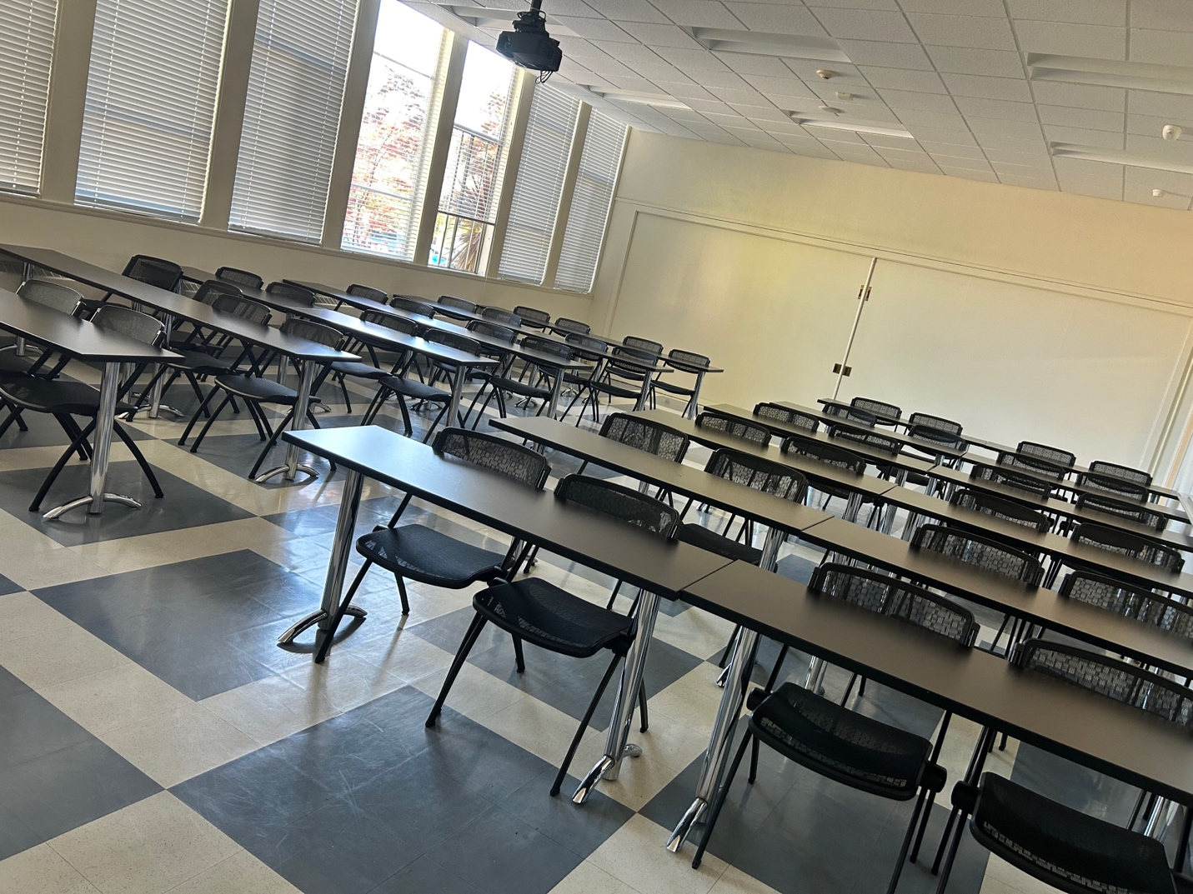

St. Mary’s 115
- Lounge
- Hybrid Technology
- Seats 30 Max

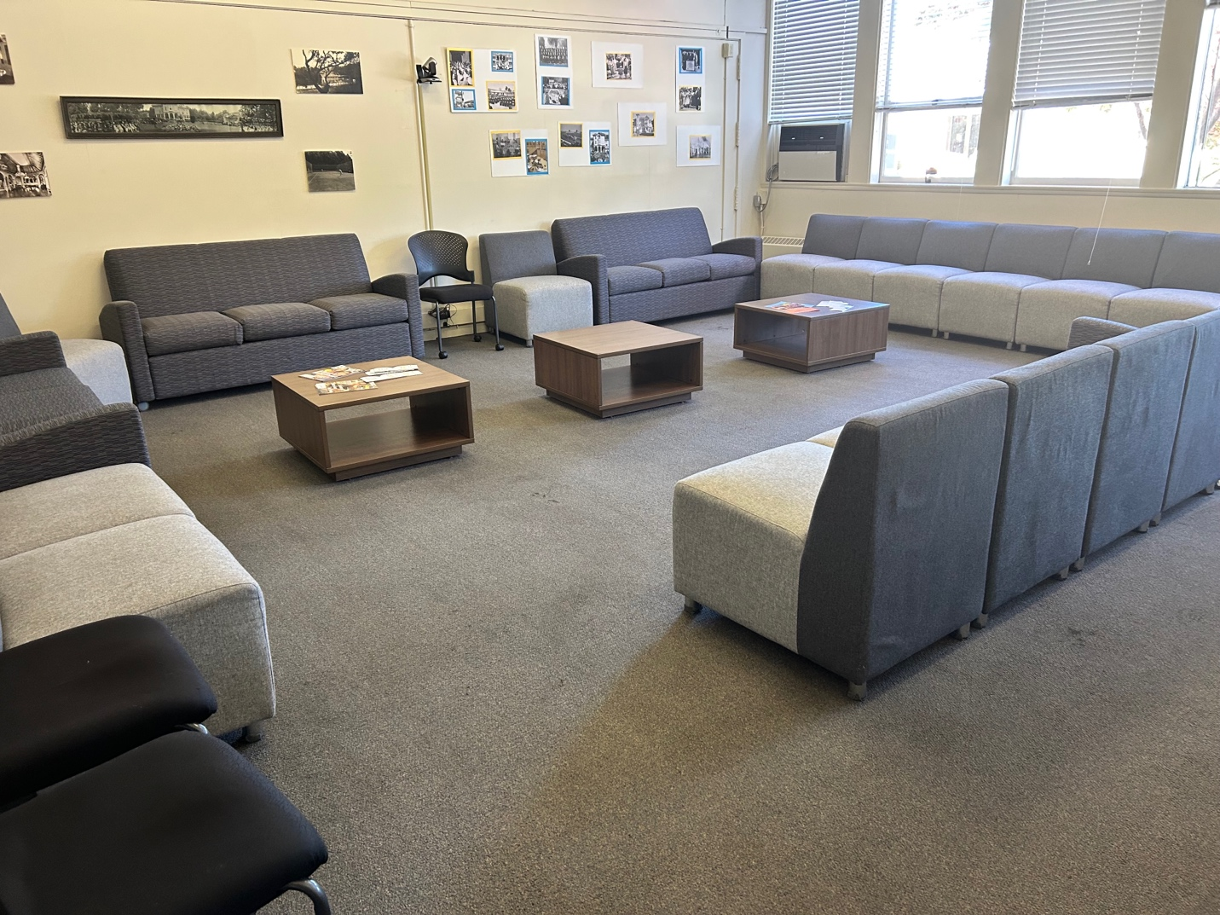

St. Mary’s 117
- Classroom
- Hybrid Technology
- Sits 24 theatre style

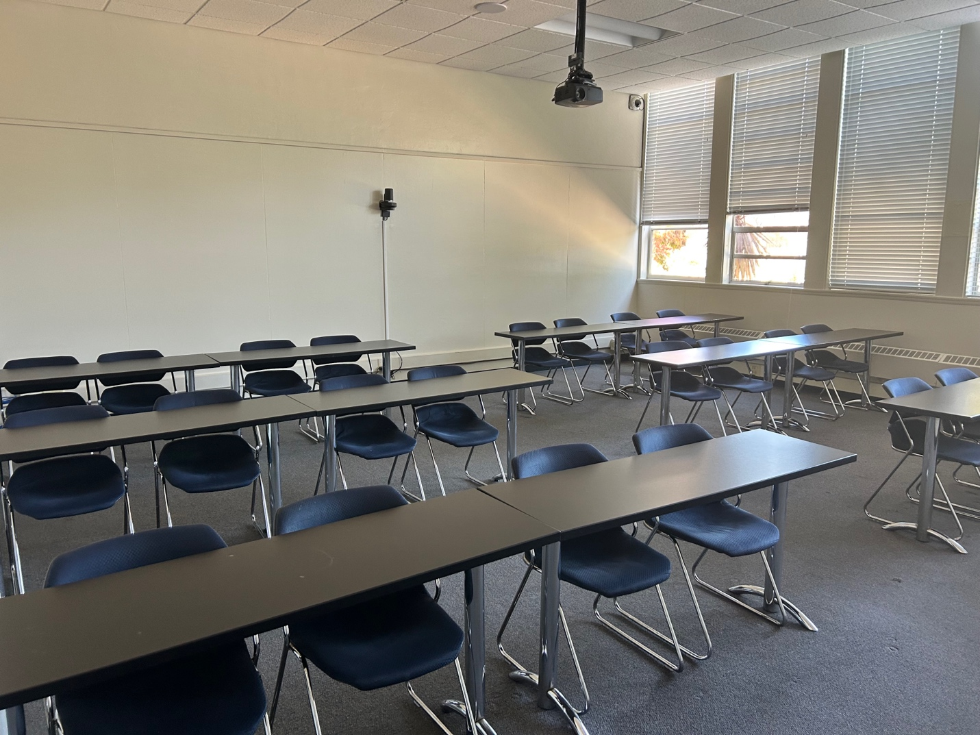

St. Mary’s 206
- Conference Room
- Hybrid Technology
- Sits 20 max

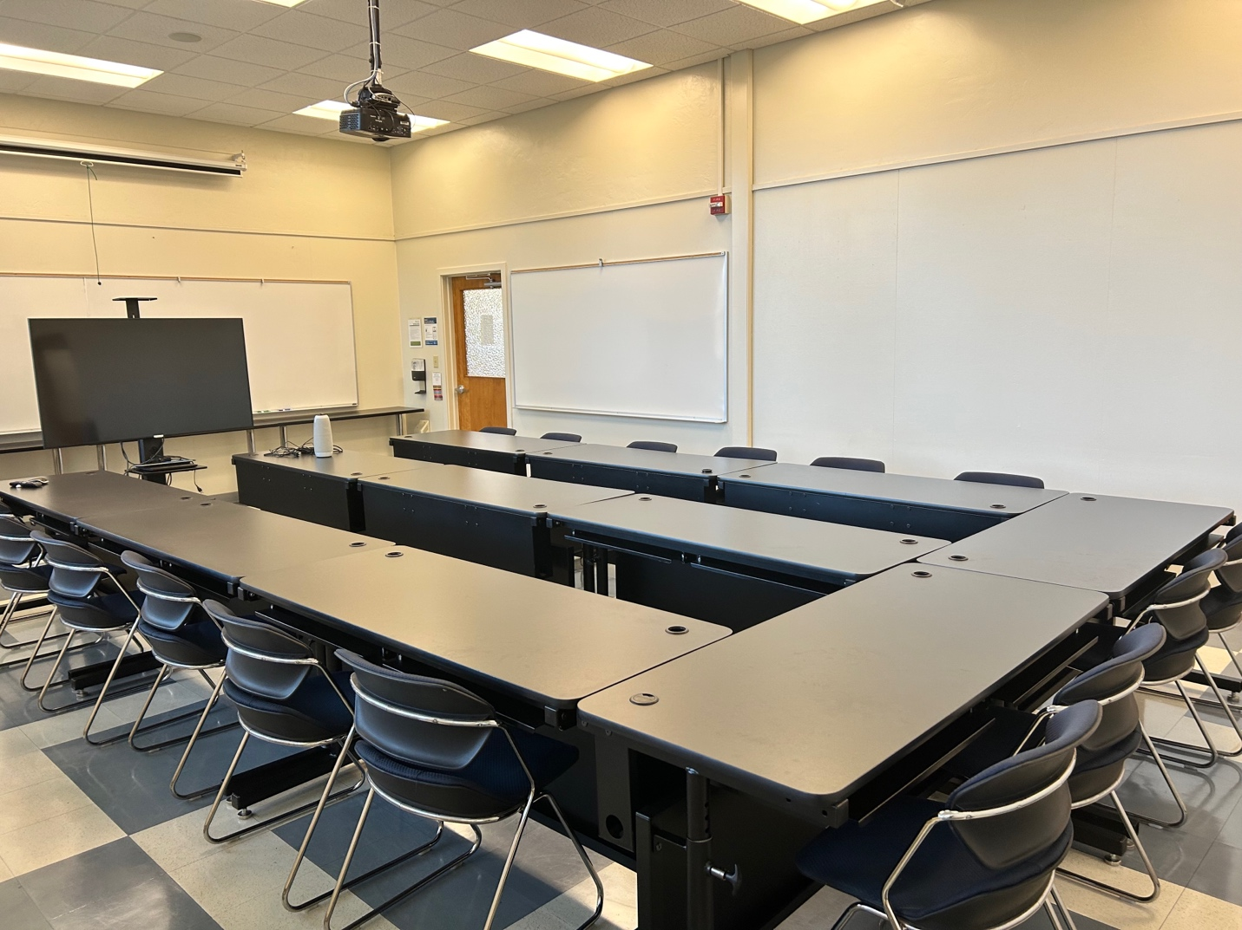

Campus Center 1 (CC1)
- Classroom
- TV to connect laptop
- Sits 15
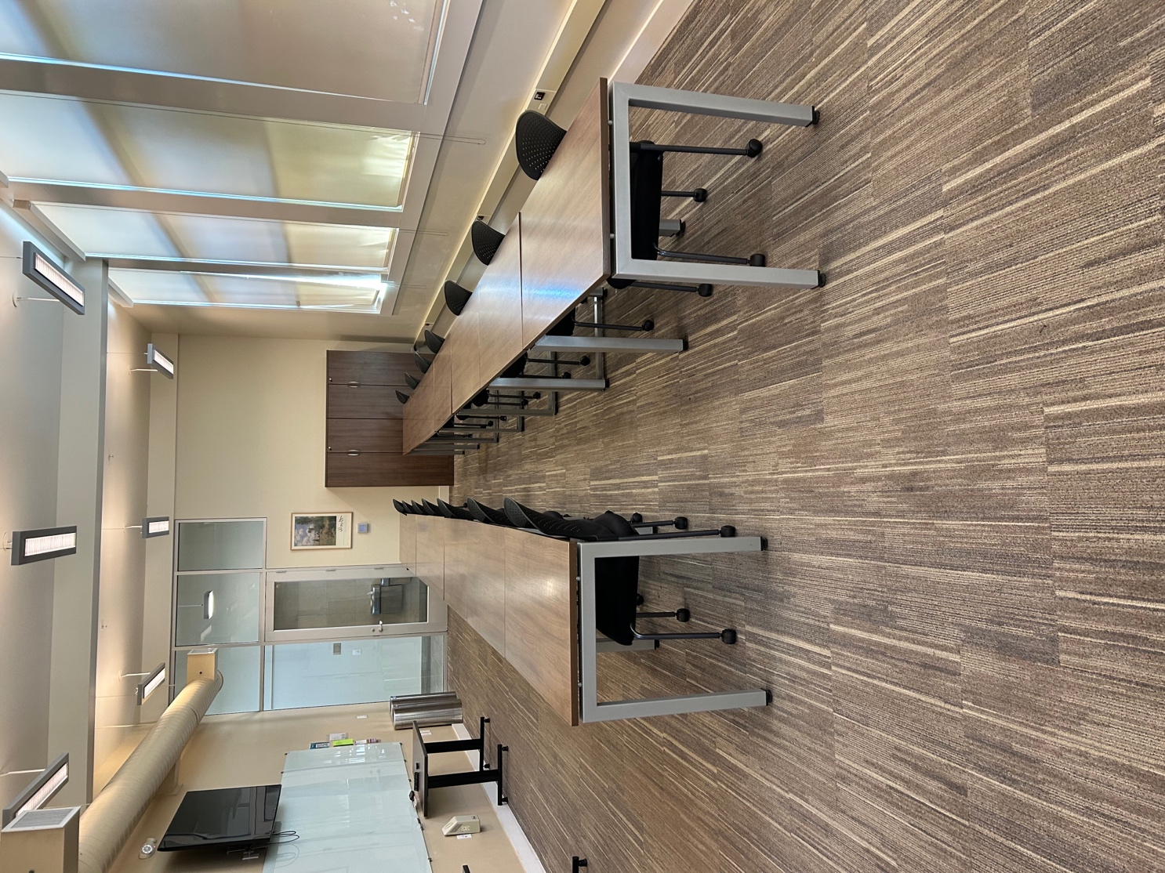

Namur Conference Room
- Conference Room
- Hybrid Technology
- Sits 9 at table
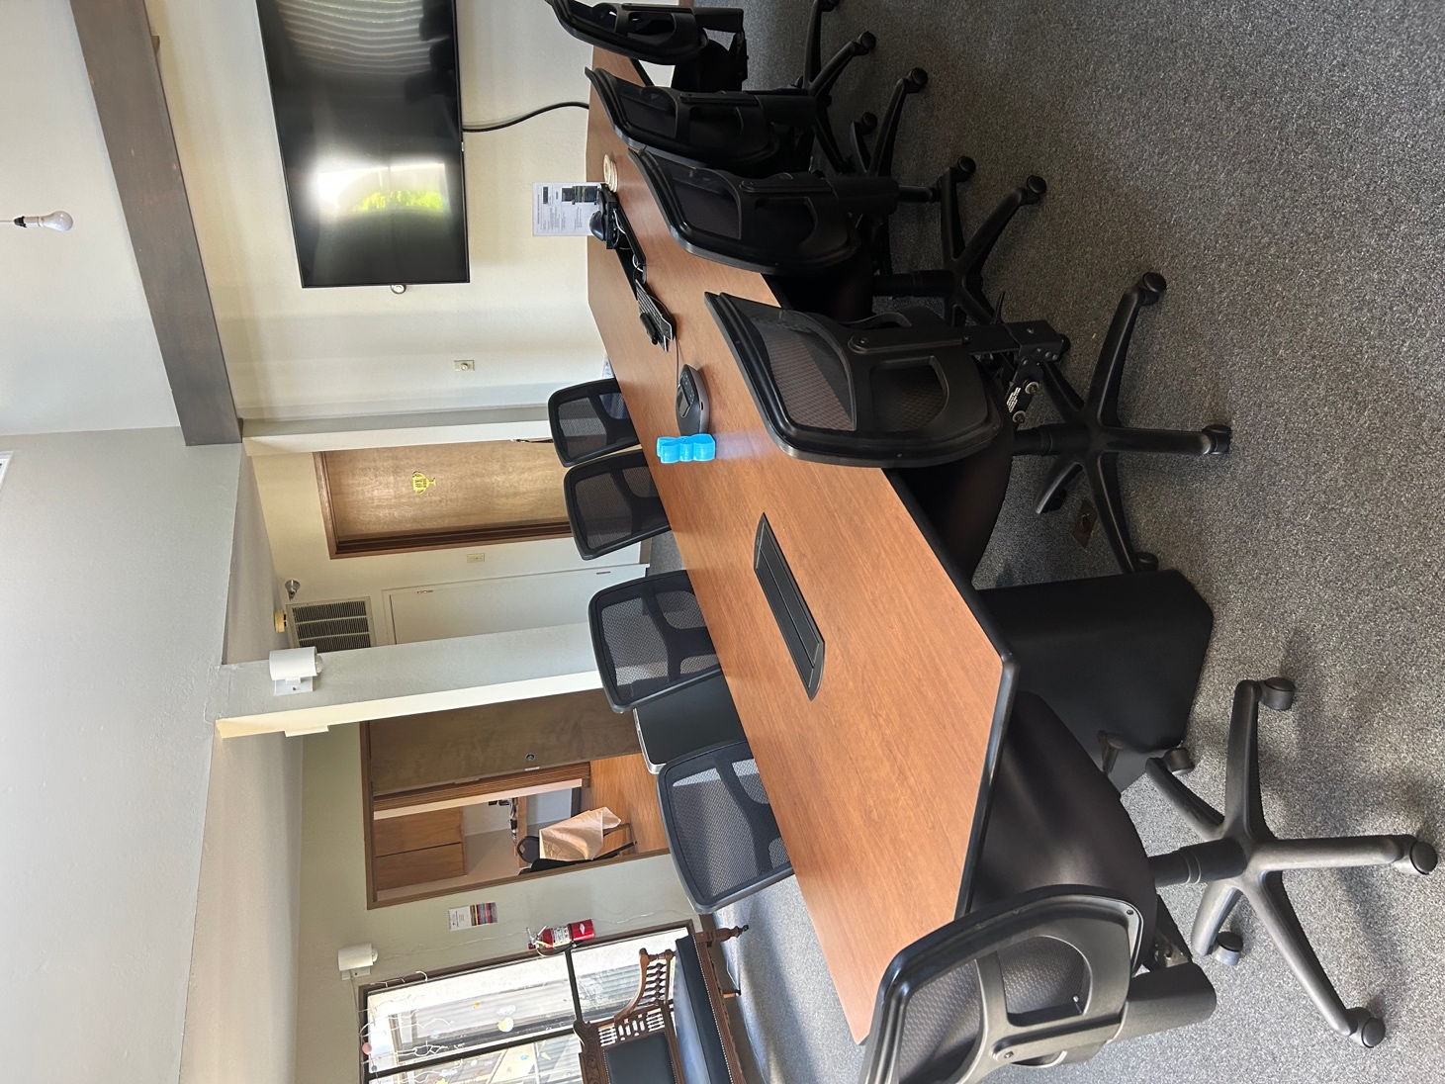

Madison Conference Room
- Conference Room
- Hybrid Technology
- Sits 10 at the table- 6 additional seats to the side.
