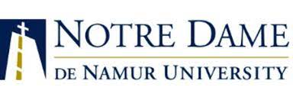
Spring 2026 Orientation Multiple and Single Subject Credential Students

Wednesday  January 7, 2026  Required for New Interns/Student Teachers  Cooperating Teachers and Intern Liaisons Invited  Online/Zoom | Thursday  January 8, 2026  Required for New Interns/Student Teachers  Cooperating Teachers and Intern Liaisons Invited  Online/Zoom
Welcome & Introductions  Block 1  4:30-5:15 pm  Presenters: Carol Piraino, Don Cox, Cynthia Rapaido | Overview of Expectations/Role of University Supervisor/Cooperating Teacher/Intern Liaison  University Supervisors Invited  Block 2  4:30-5:30 pm  Presenters:  Carol Piraino, Don Cox, Cynthia Rapaido
Recent Interns/Student Teachers Panel  5:15-6:00 pm  Student Panel: Jordan Hanlon  Q&A with First Semester Interns and Student Teachers | Support Services Presentations  5:30-6:15 pm  Presentations from  Credential Analysts  Student Academic Services
CAL TPA Introduction  Block 3  6:00-6:30pm  Presenter:  Kelly Vaughn & Kristin Stout | Closing Questions and Reminders  6:15-6:30 pm
*Tentative Agenda, check back for updates.

