Notre Dame de Namur University
School of Education
Response to General Institutional Preconditions
Date March 15, 2023
Revision Submitted: August 28, 2023
General Statement Applicable to all Preconditions for all Educator Preparation Programs: Pursuant to Education Code Section 44227 (and 44265 where applicable for Education Specialist Program) each program of professional preparation that leads to a teaching or services credential shall adhere continually to the following requirements of California State Law or Commission Policy. Each institution must respond to the general preconditions as well as all other applicable program specific preconditions.
Precondition | NDNU Response
(1) Accreditation and Academic Credit. The program(s) must be operated by  (a) Institutions of higher education: A college or university that (i) is fully accredited by the Western Association of Schools and Colleges or another of the six regional accrediting associations, and (ii) grants baccalaureate academic credit or post baccalaureate academic credit, or both. An institution approved to offer educator preparation in California must notify the Commission within 30 days if its regional accreditation status changes.  (b) School districts or other non-regionally accredited entities: The Superintendent or CEO of the district or entity shall submit a signed letter noting district leadership continued support for the program. | NDNU’s current accreditation status with the Western Association of Schools and Colleges can be found on the WSCUC website at:  https://www.wscuc.org/institutions/notre-dame-de-namur-university/  Artifacts and Evidence  WASC Letter 2015  WASC Letter 2023
2) Enrollment and Completion. Once a candidate is accepted and enrolls in an educator preparation program, the approved program sponsor must offer the approved program, meeting the adopted standards, until the candidate:  - completes the program;  - withdraws from the program;  - is dropped from the program based on established criteria; or  - is admitted to another approved program to complete the requirements, with minimal disruption, for the authorization.  In the event the program closes, a teach out plan, which includes individual transition plans for each candidate as well as a plan for candidates and graduates to access their student records would need to be developed. | NDNU offers an approved program which meets the adopted standards. The program is offered until the candidate completes the program, withdraws, is dropped from the program, or is admitted to another approved program.  Withdrawal from the Program  Candidates can elect to withdraw from the program on a temporary basis (Leave of Absence) or full withdrawal. Candidates are encouraged to meet with their Program Director to review their options and to meet with other departments of the institution to review the impact of their withdrawal, whether Leave of Absence or total Withdrawal.  Candidates who elect to leave NDNU to be admitted to another approved program to complete their program work with their Program Director and Credential Analyst. Program Directors work with candidates to ensure that course work taken meets NDNU program and CTC credential requirements as well as to review that the candidate has copies of all documents [test results, Certificate of Clearance, etc.] and knows how to order NDNU transcripts to submit to the new program. Paperwork for transfer of requirements is minimal.  Candidates dropped from the program based on established criteria: Education (Ed) Committee  The School of Education has a process for reviewing candidates who are not meeting program requirements based on adopted standards. The Ed Committee (Program Directors and 1-2 representatives from the university supervisor pool) meets monthly. The Committee reviews concerns about candidates brought by faculty and university supervisors that have been unresolved through previous supports/interventions or that raise a level of concern about the candidate’s ability to successfully complete the program or suitability for credential recommendation. The Ed Committee reviews an Education Committee Referral Form from faculty that sets out the concerns. Faculty submitting the Referral Form attend the meeting to discuss his/her concerns. At that point, the Ed Committee can recommend additional supports be provided or send a letter to the candidate setting out the concerns and inviting the candidate to meet with the committee. In meeting with the candidate, the Ed Committee determines whether 1) the candidate, with sufficient support, can successfully complete the program and develops a plan for the candidate to follow or 2) the candidate should be counseled out of the program. This is shared with the candidate at the meeting and in a letter outlining the Ed Committee recommendation. If the candidate wishes to appeal the Ed Committee decision, she/he appeals to the Dean. The Dean reviews the Ed Committee recommendation and meets with the candidate to hear the appeal. The Dean’s decision is final.  NDNU Teach-Out Policy for Program Discontinuance  The policy for initiating or terminating academic programs at Notre Dame de Namur governs the process for the discontinuance of an academic program. This Teach-Out Policy for Program Discontinuance becomes effective when the decision has been made to discontinue an academic program. Its purpose is to ensure that students enrolled in a terminated program receive written and timely notification and are provided alternatives for completing the program in a specified period of time.  When a Teach-Out action is required, the University and Board of Trustees shall consider the following options:  1. NDNU teaches out currently enrolled students; no longer admits students to programs; and terminates the program after all students (who meet the requirements described below) have graduated.  2. NDNU enters into a formal contract with another institution to teach out students currently enrolled in the academic program.  Only those students who maintain continuous enrollment during the teach-out period shall be guaranteed the opportunity for program completion. Students who do not meet university and program academic standards, are not continuously enrolled in accordance with university regulations, and do not comply with teach-out conditions shall not be guaranteed program completion.  Teach-Out Agreements  A teach-out agreement is defined as a written agreement between NDNU and one or more institutions that provide an avenue for students to complete the program, either through an on-site program or via mediated instruction.  NDNU shall enter into an agreement with a teach-out institution that is accredited by a regionally/nationally recognized accrediting agency and that has the necessary experience, resources, and support services to provide an educational program of comparable quality and similar in content to that provided by NDNU.  Excerpted from NDNU’s Governance Handbook, approved by the Board of Trustees December 10, 2014  Artifacts and Evidence  Leave of Absence/Withdrawal forms: https://ndnuregistrar.typeform.com/to/YelTMi9o?typeform-source=campusportal.ndnu.edu  Education Committee Referral Form  Artifacts and Evidence  Education Committee Referral Form
(3) Responsibility and Authority. To be granted continuing accreditation by the Committee on Accreditation, the entity shall provide the following information:  (a) Identify the position within the organizational structure that is responsible for ongoing oversight of all educator preparation programs offered by the entity (including educator preparation programs offered by an extension division, if any).  (b) Provide a description of the reporting relationship between the position described in (a) and the individual(s) who coordinate each educator preparation program offered by the entity. If a reporting relationship is indirect, describe the levels of authority and responsibility for each educator preparation program. Include an organizational chart for the institution as well as the division(s) within the institution responsible for the oversight of educator preparation programs; include any parent organization, outside organization(s), or partner(s) who will be involved in the oversight of the educator preparation unit and/or responsible for any aspect of program delivery.  © Provide policies to ensure that duties regarding credential recommendations are provided solely by persons who are current employees of the Commission approved institution. | (a) The Dean of the School of Education is responsible for ongoing oversight, both academic and fiscal, of all educator preparation programs offered by Notre Dame de Namur University. The Dean serves as the liaison with all local, state, and national agencies with bearing on the credential programs.  (b) Notre Dame de Namur (NDNU) School of Education has 4 Program Directors, one for each credential program [Multiple Subject, Single Subject, Special Education, and School Administration (pASC)] who are responsible for coordinating their credential program. The Program Directors report directly to the Dean.  Artifacts and Evidence  NDNU Organizational Chart  https://www.ndnu.edu/wp-content/uploads/Org-Chart-NDNU-03-08-2023.pdf  The School of Education has a full-time Credential Analyst who has been a Credential Analyst since 2008. He stays current in the field, consulting with colleagues, attending yearly CCAC Conference each fall, and workshops/webinars provided by CTC.  Artifacts and Evidence  Credential Analyst Job Description
(4) Lawful Practices. To be granted continuing accreditation by the Committee on Accreditation, a program of professional preparation must be proposed and operated by an entity that makes all personnel decisions without unlawful discrimination. These decisions include decisions regarding the admission, retention or graduation of students, and decisions regarding the employment, retention, or promotion of employees. | NDNU makes all personnel decision, as well as decisions regarding the admissions, retention, or graduations of students, and decisions regarding employment, retention, or promotion of employees without unlawful discrimination.  Artifacts and Evidence  NDNU Employment  https://www.ndnu.edu/human-resources/jobs/  Polices  Know Your Rights….  https://www.eeoc.gov/sites/default/files/2022-10/EEOC_KnowYourRights_screen_reader_10_20.pdf  Employee Handbook  https://www.ndnu.edu/documents/human-resources/Employee-Handbook.pdf  Students/Candidates  Catalog  https://ndnu.edu/documents/academics/NDNU-2022-2023-Graduate-Catalog.pdf  need link to title on p. 9  Admissions  https://www.ndnu.edu/admissions/admissions-requirements/  Student Handbook  https://ndnu.edu/documents/resources/NDNU-Student-Handbook-2022-2023.pdf
(5) Commission Assurances. To be granted continuing accreditation by the Committee on Accreditation, the program sponsor must:  - (a) assure that the sponsor will fulfill all of the applicable standards of program quality and effectiveness that have been adopted by the Commission,  - (b) assure that all candidates participating in public school-based field activities hold a Certificate of Clearance from the Commission,  - © assure that the approved program sponsor will cooperate in an evaluation of the program by an external team or a monitoring of the program by a Commission staff member, and  - (d) assure that the approved program sponsor will participate fully in the Commission’s accreditation system, including the timely submission of documents required for accreditation. | Artifacts and Evidence  Assurances Letter from Dean
(6) Requests for Data. To be granted continuing accreditation by the Committee on Accreditation, the entity must identify a qualified officer responsible for reporting and responding to all requests from the Commission for data including, but not limited to, program enrollments, program completers, examination results, including performance assessments, and state and federal reporting within the time limits specified by the Commission. Institutional contact information must be updated annually. | The Credential Analyst is the designated qualified officer responsible for reporting and responding to the requests for data including, but not limited to, program enrollments, program completers, examination results, performance assessment, and state and federal reporting within the time limits specified by the Commission. The Credential Analyst collaborates with Program Directors, the Teaching Performance Assessment Coordinator, the Registrar’s Office, the Admissions Offices, the Office of Institutional Research to obtain these data. The Dean of the School of Education is responsible for ongoing oversight of reporting data to the Commission.  The School of Education understands it is the institution’s responsibility to check the contact information listed on the California Commission on Teacher Credentialing NDNU’s approved programs page and to make updates at least on an annual basis, or more frequently to assure information is current.  Artifacts and Evidence  Credential Analyst Job Description
(7) Veracity in all Claims and Documentation Submitted. To be granted continuing accreditation by the Committee on Accreditation, the entity must positively affirm the veracity of all statements and documentation submitted to the Commission. | Artifacts and Evidence  Veracity Letter from Dean
(8) Grievance Process. To be granted continuing accreditation by the Committee on Accreditation, the approved program sponsor must have a clearly delineated grievance process for candidates and applicants. The grievance process information must be accessible to all candidates and applicants and the institution must be prepared to provide documentation that candidates have been informed of the grievance process and that the process has been followed. | NDNU has a clearly delineated grievance process for candidates and applicants which is available through the following:  Artifacts and Evidence  Catalog  https://ndnu.edu/documents/academics/NDNU-2022-2023-Graduate-Catalog.pdf  need link to page 13  Student Handbook  https://ndnu.edu/documents/resources/NDNU-Student-Handbook-2022-2023.pdf  need to link to page 32  New Student Orientation Agenda  Artifacts and Evidence  New Student Orientation Agenda
(9) Faculty and Instructional Personnel Participation. All faculty and instructional personnel employed by colleges and universities who regularly teach one or more courses in an educator preparation program leading to a credential, shall actively participate in the public school system at least once every three academic years, appropriate to their credential area. Faculty who are not in the Department, School or College of Education are exempt from this requirement. Reference: Education Code Section 44227.5 (a) an d (b). | All NDNU faculty and instructional personnel who regularly teach one or more courses or supervise candidates in practicum placements actively participate in the public school system at least once every three academic years, appropriate to their credential area.  For full-time faculty and part-time faculty not currently employed in public schools, participation includes providing professional development workshops/support in partner TK-12 public schools, volunteering in classroom settings, providing professional development to teachers and administrators, and supervising student and intern teachers in clinical fieldwork settings.  For part-time faculty who are currently employed in public districts/schools as full-time teachers or administrators, their job fulfills this requirement.  Artifacts and Evidence  Faculty Participation Table  Artifacts and Evidence  Faculty Participation Table
(10) Communication and Information. To be granted continuing accreditation by the Committee on Accreditation, the approved program sponsor must provide easily accessible and accurate information to the public, prospective educators, and enrolled candidates about the requirements for admission and successful completion for all its educator preparation programs. | Accurate information to the public, prospective educators, and enrolled candidates about requirements for admission and successful completion of NDNU educator preparation programs can be found on the websites listed below. Each credential program also has a program specific webpage with information about the program, admissions requirements, and links to the General Catalog for course descriptions.  Artifacts and Evidence  School of Education website: https://www.ndnu.edu/school-of-education/  MA School Administration [pASC] website: https://www.ndnu.edu/school-of-education/masa/  Single Subject Credential website: https://www.ndnu.edu/school-of-education/credentials-single/  Multiple Subject Credential website: https://www.ndnu.edu/school-of-education/credentials-multiple/  Education Specialist Credentials website: https://www.ndnu.edu/school-of-education/mase/  Admissions Requirements website: https://www.ndnu.edu/admissions/admissions-requirements/  General Catalog link: https://ndnu.edu/documents/academics/NDNU-2022-2023-Graduate-Catalog.pdf
(11) Student Records Management, Access, and Security. To be granted continuing accreditation by the Committee on Accreditation, the sponsor must demonstrate that it will maintain and retain student records in accordance with the institution’s record retention policy. Institutions will provide verification that:  (a) Candidates and graduates will have access to and be provided with transcripts and/or other documents for the purpose of verifying academic units and program completion.  (b) All candidate records will be maintained at the main institutional site or central location (paper or digital copies).  © Records will be kept securely in locked cabinets or on a secure server located in a room not accessible by the public. | The Registrar’s Office is the official recorder and keeper of student academic records. The Registrar’s Office has a “document retention policy”. Records are maintained in compliance with federal privacy regulations (FERPA). The Education Department retains student files for 10 years. Archived files are kept in locked cabinets in a locked room in St. Mary’s Hall. The key must be obtained from the Credential Analyst or the School of Education Executive Assistant to the Dean. Current files are in locked file cabinets in the Credential Analyst’s Office.  Candidates and graduates have access to transcripts and/or other documents for the purpose of verifying academic units and program completion thought their individual Campus Portal site, by requesting information from the Dean’s office, Credential Analyst, their Program Director and/or the Registrar.  Artifacts and Evidence  Campus Portal website: https://campusportal.ndnu.edu/ics/  Official transcripts can be ordered at any time through the website: https://www.studentclearinghouse.org/
(12) Disclosure. Institutions must disclose information regarding any outside organizations that will be providing any direct educational services as all or part of the educator preparation programs sponsored by the institution and identify the type of services the outside organization will provide. | No outside organizations provide any direct educational services as all or part of the institutions educator preparation programs.

WASC Letter 2015
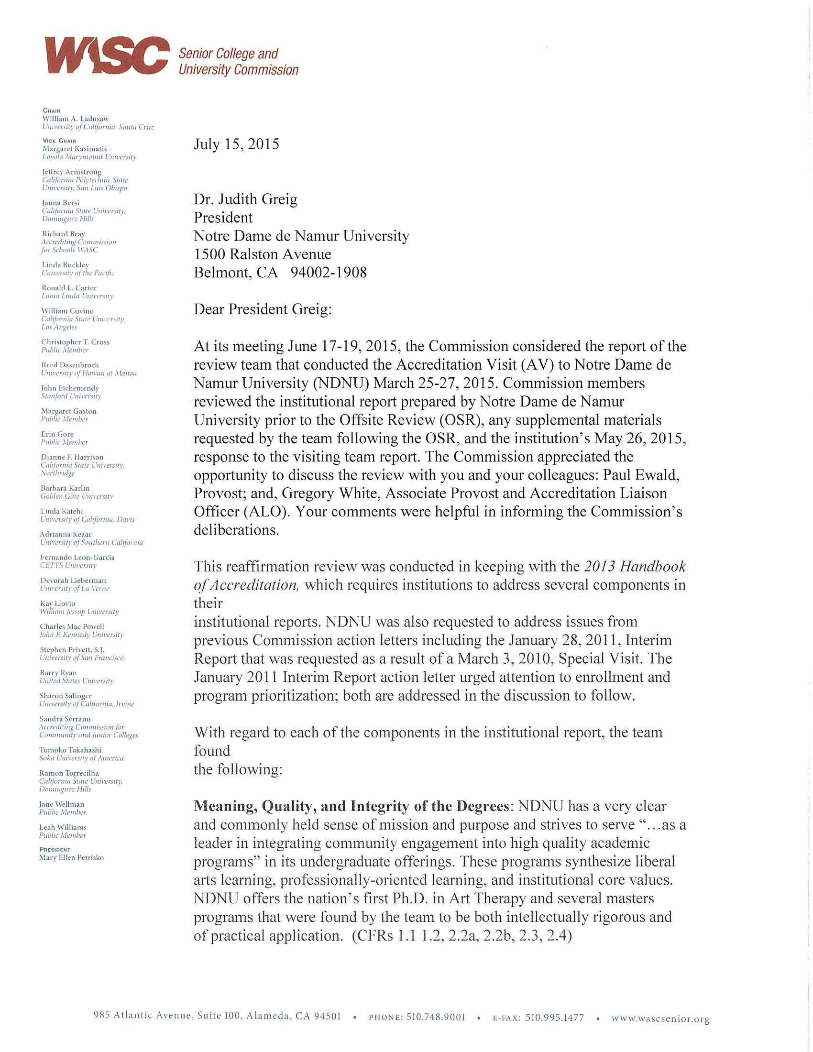



July 14, 2023

Dr. Lizbeth Martin President
Notre Dame De Namur University 1500 Ralston Avenue
Belmont, CA, 94002 Dear President Martin:
This letter serves as formal notification and official record of action taken concerning Notre Dame De Namur University (NDNU) by the WASC Senior College and University Commission (WSCUC) at its meeting June 30, 2023. The Commission appreciated the opportunity to discuss the visit with you and your colleagues Gregory White, Provost and Senior Vice President/ALO, Kurt Allen, Vice President for Marketing, and Sr. Mary Farren, Leadership Team, SNDdeN US East-West Province. Your comments were very helpful in informing the Commission’s deliberations.

At that meeting, after considering the Institutional Report and exhibits submitted by NDNU, the Report of the April 26-28, 2023 Special Visit to NDNU, and the institution’s response to the team report, the Commission determined that there should be no change to the institution’s accreditation status. Accordingly, the institution remains on Warning. The Commission also scheduled a Progress Report to be submitted by October 15, 2023, to provide an update on the institution’s progress in addressing its compliance with Standards 3 and 4.

NDNU has made improvements in operational integrity, support for student academic success, capacity to develop and deliver online programs, improved use of data for marketing, and shared governance.

The Commission found that NDNU has not demonstrated compliance with Standard 3. Under WSCUC policies, when the Commission finds that an institution fails to meet one or more of the Standards of Accreditation, it is required to notify the institution of the deficiencies and establish a time period within which the deficiencies must be corrected. Under the Commission’s policies the timeframe may not exceed two years. If the Commission determines that the institution has not remedied the deficiencies at the conclusion of this sanction period, the Commission will withdraw the institution’s accreditation or grant an extension of the timeframe for good cause shown which may not exceed two years.

NDNU has been on Warning since March 2022, which means the two-year sanction period will expire in March 2024. The institution must demonstrate, through a Special Visit, that it complies with the Standards. The institution may request an extension of the timeframe if it can demonstrate significant accomplishments in addressing the areas of noncompliance during the period of sanction AND demonstrate at least partial compliance with the Standard(s) cited, and for any remaining deficiencies, demonstrate an understanding of those deficiencies and readiness, institutional capacity and a plan to remedy those deficiencies

within the period of extension granted by the Commission.¹

The accreditation status of the institution continues during Warning. While on Warning, any new sites or degree programs initiated by the institution must be approved through the substantive change process.

Actions

- Receive the Special Visit team report that focused on financial sustainability
- Continue a Warning
- Continue with the previously scheduled reaffirmation review with the Offsite Review in spring 2024 and the Accreditation Visit in fall 2024
- Schedule a Special Visit in fall 2023 to address the issues outlined below.

Issues to be Addressed

  - Finance
NDNU does not demonstrate compliance with CFR 3.4 due to structural deficits as a result of continuous enrollment declines. NDNU must expeditiously demonstrate a long-term financial plan sufficient for fiscal sustainability. (CFR 3.4)
  - Planning
The university has not fully demonstrated integrated planning that aligns academic program strategy and long-term enrollment growth plans. NDNU has eliminated its in-person undergraduate programs and transitioned to providing online and hybrid professional graduate and bachelor completion programs. It has also begun to develop new programs. NDNU must implement a clear process for alignment of academic program strategy with enrollment growth plans that inform multi-year budget development and scenario planning with all relevant stakeholders. In addition, NDNU must align operational, financial, and academic activities to grow the enrollment in their programs consistent with its mission and educational objectives. Growth in net tuition revenue is critical to the long-term financial viability of NDNU. The budgeted increase in fall 2023 net revenue as outlined in NDNU’s draft FY2024 budget is a significant part of the financial plan. NDNU needs to validate their new budgeting and enrollment processes and the underlying assumptions for enrollment growth using fall 2023 enrollment as its initial key datapoint. (CFRs 3.4 and 4.6)

Further Recommendations
- NDNU has begun to review, update, and create operational and academic policies. The recently reconstituted faculty governance committee has not had time to complete the formation of academic policies and procedures. NDNU leadership must continue this effort and improve communication about its plans

¹ WSCUC Handbook of Accreditation, Part IV: Commission Decisions on Institutions, Forms of Possible Commission Action, Sanctions, p. 4 of 6.

to stakeholder groups, in particular to its students, faculty, staff and the surrounding community. (CFR 1.7)
- The college should ensure sufficient faculty capacity to provide adequate support for the institution’s academic objectives. (CFR 2.2b)
NDNU is required to provide updated notifications of this continuing status to all current and prospective students within seven days of receipt of this letter. For prospective students, the notice must be available on NDNU home page of its website. NDNU must provide a copy of that notice to the Commission within the same seven-day period.

Institutions issued a Warning may request a review of this decision within 28 days of receiving the Commission’s Action Letter according to the procedures outlined on pages 40- 42 of the WSCUC 2013 Handbook.

In accordance with Commission policy, a copy of this letter is being sent to the chair of NDNU’s governing board. The Commission expects that the team report and this action letter will be posted in a readily accessible location on the NDNU’s website and widely distributed throughout the institution to promote further engagement and improvement and to support the institution's response to the specific issues identified in these documents. The team report and the Commission’s action letter will also be posted on the WSCUC website. If the institution wishes to respond to the Commission action on its own website, WSCUC will post a link to that response on the WSCUC website.

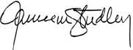
Please contact me if you have any questions about this letter or the action of the Commission. Sincerely,

Jamienne S. Studley President

JSS/thh

Cc: Phillip Doolittle, Immediate Past Chair Tracy Poon Tambascia, Chair
Gregory White, ALO Jean Stoner, Board Chair
Members of the Special Visit team Tamela Hawley, Vice President

CREDENTIAL ANALYST JOB DESCRIPTION

TITLE: Credential Analyst
REPORTS: Dean, School of Education and Leadership
STATUS: Full-time, Exempt

GENERAL DESCRIPTION:
The Credential Analyst collaborates with the California Commission on Teacher Credentialing (CCTC) to ensure that each credential candidate from Notre Dame de Namur University (NDNU) meets all California Commission on Teacher Credentialing (CTC) standards for credential recommendation. The Credential Analyst provides services to credential candidates throughout their experiences at NDNU, helping to ensure a smooth progression from applicant to credentialed teacher and alumnus. Thus, the position entails evaluation prior to admission, monitoring of status in regard to statutory and program requirements during the preparation program, and assistance in the transition of candidates to the job search and professional induction. The Credential Analyst position is required by the California Commission on Teacher Credentialing (CTC).

SPECIFIC RESPONSIBILITIES/DUTIES:
- CTC Compliance: The Credential Analyst collaborates with CTC to ensure that each NDNU candidate meets all standards for credential recommendation. Specific responsibilities include:
- Evaluate and document status of candidates during admission process into all credential programs (four credential programs and one Administrative Services credential programs)..
- Review and evaluate all college/university transcripts of all admitted and current credential candidates to determine whether their course work fully meets, partially meets, or does not meet CTC subject matter domain requirements for basic skills verification and subject matter competency verification; complete CTC documentation for candidate files and to submit at the point candidate completes the program and are recommended for a credential. Advise candidates who only partially met or did not met either of these requirements on next steps to complete this requirement either through additional coursework or CTC tests.
- Work with Placement Coordinators and Program Directors to verify that candidates have submitted all documents required as completed course work required by Preconditions to be eligible for enrollment in student teaching or recommendations for an intern credential
- Determine candidate status for institutional recommendation to CTC for credentials; prepare appropriate documentation and submit credential application packets to CTC in timely fashion throughout the calendar year.
- Track candidates on intern credentials. Work with Program Directors and district HR staff to ensure candidates on intern credentials remain enrolled in coursework until they are eligible for recommendation for preliminary credential; apply for extensions as required.
- Work with private school teachers eligible to apply directly to the CTC for a Multiple Subject or Single Subject teaching credential per CL-834. Explain the process, advise as they assemble a packet for submission; review the packet prior to submission to the CTC.
- Prepare and ensure timely submission of program information required yearly in conjunction with federal Title II reporting and CTC Accreditation Data System (ADS).

- Communication Interface: The Credential Analyst provides credential information and services to candidates throughout their program. Specific responsibilities include:
- Meet and provide credential information to applicants and candidates as needed; advise applicants and candidates of California credentialing law; do follow up mailings to candidates with respect to completion of individual files.
- Advise NDNU, School of Education (SOE), SOE faculty, and credential candidates (2as appropriate) of upcoming changes in credentialing requirements.
- Provide candidates with appropriate information and services with respect to educational placement; inform candidates of options governed by federal and state statutes regarding the establishment and maintenance of professional files.
- Arrange Job Fair and interviews with school districts for second semester student teachers and provide materials and guidance for the job search process.
- Make available to candidates information received regarding districts, schools, and job openings.
- Inform out-of-state trained teachers applying for California credentials of coursework and programs available to them at NDNU to fulfill specific California requirements.
- Work with county, public school district offices, private schools, and agencies regarding legal certification (CTC) of NDNU candidates and graduates and out-of-state candidates.
- Serve as resource on credential procedures for teachers and administrators who are members of the regional education community.
- Update form letters, checklists, etc. annually or as requirements are changed.

4) Record Management: The Credential Analyst prepares and maintains detailed and accurate
records for all candidates and graduates and the various credential programs offered by the
School of Education. Specific responsibilities include:
- Work with Placement Coordinators to maintain a database and individual files of all documentation required for credential recommendation; inform credential candidates of missing requirements.
- Continue to maintain professional files for credential and education degree graduates on an as-needed basis.
- Interface with NDNU institutional database with respect to student records.
- Work with NDNU Enrollment Management, Registrar, and Business Office regarding candidate readiness for admission, enrollment, retention issues, program completion, commencement, etc.
- Comply with CTC guidelines for ongoing program evaluation. Maintain files for regular CTC audits.

- Other:
- Participate in California professional organization of Credential Analysts
- Attend regional and statewide trainings offered by the CTC on regular basis.
- Link NDNU with U.S. Constitution exam website. Provide support and assistance for NDNU and non-NDNU credential candidates with accessing and utilizing the site.
- Attend NDNU meetings:
  - Attend monthly Education Committee meetings.
  - Attend monthly School of Education meetings.
  - Attend Department of Teacher Education meetings as scheduled.
  - Attend New Student Orientation each semester
- Attend Student/Intern Teaching Seminars every semester to sessions to provide credential information.
- Attend yearly Advisory Council meetings.
- Perform other duties as assigned by the Dean of School of Education and Leadership.

QUALIFICATIONS:
- Bachelor’s degree required; teaching credential and/or master’s degree preferable
- Teaching experience or administrative experience in school setting desirable
- Knowledge of current California laws, Education Codes, CTC standards governing teaching credentials and program accreditation.
- Understanding of NDNU’s approved credential programs
- Knowledge of NDNU admission requirements and procedures
- Ability to create databases and maintain highly organized files
- Ability to compile, organize, interpret, and evaluate data
- Ability to assess individual candidates’ records in relation to current law and program guidelines related to teacher credentialing
- Ability to communicate well orally, including large group presentation
- Ability to communicate well in writing, including advanced word processing skills
- Ability to work cooperatively in team setting while maintaining appropriate confidentiality
- Mature professional with good judgment

Revised: 10.10.22



Student Name: | Program Name:
Committee review date: | Program Director:
Relevant Persons to be Invited (e.g. supervisor, MT, placement coordinator:
Education Committee Referrel Form

Identify the issue(s) to be reviewed by the Education Committee:

Recommendations from the Ed Committee during review:

Attach documentation:
- Transcript
- Instructor Summary of problem or event
- Master Teacher Summary of problem or event
- Professional Checklist
- Copy of email correspondence with student
- Another supporting document

Program Director Signature: ________________________________________Date: _____________________________

School of Education Faculty TK-12 Participation
2022-2023

Name | Status FT or PT | NDNU Position | Public School Participation
Ayala, Kristina | PT | Teaching & Pedagogy Mentor | Full-time teacher
Bennett, Edith | PT | Special Education Instructor | District Psychologist
Buttrill, Judith | PT | Special Education Instructor | Former Special Education teacher; Intructor Reading/Language Arts Primary Grades course for Multiple Subject and Educationa Specialist candidates; University Suepervisor - Observe ST/Intern candidates in school; collaborate with Master Teachers/ District Employed Intern Supervisors
Cespedes, Erin | PT | Teaching & Pedagogy Mentor | Fill-time teacher
Charles, susan | PT | Program Director pASC Program; IpASC Instructor & University Supervisor; Foundation course instructor | Former teacher and schoo/district administrator; Observe candidates in schools; collaboration & teacher/administrator PD with partner districts
Chen, Julie | PT | Teaching & Pedagogy Mentor | Fill-time teacher
Constantino, Julie | PT | Multiple Subject & Special Education Placement Coordinator; Multiple Subject Instructor & University Supervisor | San Mareo County Office of Eduaction Induction Mentor; Borel Middle School School Site Counceil member; Coordinates candidates placements with local districts; Observe candidates in schools; Coordinates candidates placements with local districts; Observe candidates in schools; Collaboration & teacher/administrator PD with partner districts; Coordinate and lead Master Teacher/District Employed Supervisor training every semester
Cox, Don | PT | pASC Instructor & University Supervisor | Former teacher & school/distrcit administrator; Observe pASC candidates in schools; collaborate with school administration
Crosby, Brooke | PT | Special Education Instructor | Former Special Education teacher; District Assistant Director of Special Education & Principal of Hillside Pre-School
Delaney, Kelly | FT | Program Director, Single Subject Program; Instructor Foundations & Single Subject courses; Single Subject University Supervisor | Former middle school teacher; University Supervisor - Observe ST/Intern candidates in school; collaborate with Master Teachers/ District Employed Intern Supervisors; Pipeliine Committee – collaborate with districts to provie professinal development for teachers, jointly recruitdistrict personnnel, aides, substitute techers, etc. into credential program); Organization team and volunteer teacher for a 4-week all day K-8 summer school program that was a joint venture between Cabrillo Unified School District and ALAS. Students were all English Learners and the main focus of the summer school curriculum was literacy and academics in the morning with P.E., Music and arts in the afternoon.
Demaree, Stephanie |  | Program Director, Multiple Subject Program; Chair Education Committee; TPA Coordinator; Multiple Subject Instructor & University Supevisor; NASA Solar Sytem Ambassador | Former teacher; University Supervisor - Observe ST/Intern candidates in school; collaborate with Master Teachers/ District Employed Intern Supervisors; From 2012-2020, Drs. Demaree and Vaughn coordinated and implemented free Common Core State Standards Math after-school tutoring programs at 5 different high-needs Bay Area Elementary Schools. Since 2020, Dr. Demaree has been a NASA Solar System Ambassador, teaching the public about science and discoveries regarding NASA directives and missions at the San Mateo County Public Library System; Science teacher for 4-week all day K-8 summer school program that was a joint venture between Cabrillo Unified School District and ALAS.
Drabkin, Inesa | PT | Teaching & Pedagogy Mentor | Retired Teacher mentoring candidates in their classroom placements in specific academic content area
Bennett- Ennon, Cathelyn | PT | Single Subject Instructor & University Supervisor | Former Middle School Teacher; MS Principal; University Supervisor - Observe ST/Intern candidates in school; collaborate with Master Teachers/ District Employed Intern Supervisors;
Fox, Janet | PT | Special Education Instructor & University Supervisor | Former Special Education Teacher; MS Principal; University Supervisor - Observe ST/Intern candidates in school; collaborate with Master Teachers/ District Employed Intern Supervisors;
Gadus, Brian | PT | Special Eeducation Assistive Technology Instructor | School District Assistive Teachnology Teacher
Grotans, Helene | PT | Teaching & Pedagogy Mentor | Full-time Teacher
Ho, Cherie | PT | Single Subject University Supervisor | Former teacher; Observe ST/Intern candidates in school; collaborate with Master Teachers/ District Employed Intern Supervisors;
Ingersoll, Janet | PT | Multiple Subject University Supervisor | Former teacher and district/school administrator; Observe ST/Intern candidates in school; collaborate with Master Teachers/ District Employed Intern Supervisors;
Jacobs, Terry | PT | Special Education Instructor & University Supervisor | Former Special Education teacher; University Supervisor - Observe ST/Intern candidates in school; collaborate with Master Teachers/ District Employed Intern Supervisors;
Johnston, Beatrix | PT | Teaching & Pedagogy Mentor | Retired Teacher mentoring candidates in their classroom placements in specific academic content area
Jump, Otak | PT | Single Subject University Supervisor | Former teacher & district/school administrator; University Supervisor - Observe ST/Intern candidates in school; collaborate with Master Teachers/ District Employed Intern Supervisors;
Knott, Christy | PT | Instructor General Education courses; Single Subject Supervisor; InSpace Coordinator | Former teacher; University Supervisor - Observe ST/Intern candidates in school; collaborate with Master Teachers/ District Employed Intern Supervisors; Coordinates IN Space training for faculty and staff
Larragoiti, Sandra | PT | Multiple Subject University Supervisor | Former teacher & district/school administrator; University Supervisor - Observe ST/Intern candidates in school; collaborate with Master Teachers/ District Employed Intern Supervisors;
Malek-Salehi, JIla | PT | Single Subjecct Placement Coordinator; University Supervisor | Teacher; Observe ST/Intern candidates in school; collaborate with Master Teachers/ District Employed Intern Supervisors;
McGuigan, Diane | PT | Multiple Subject Instructor | Elementary School Teacher
Musante, Virginia | PT | Teaching & Pedgogy Mentor | Retired Teacher mentoring candidates in their classroom placements in specific academic content area
Nida, Jill | PT | Teaching & Pedgogy Mentor | Full time teacher
Norgaard, Kim | PT | Multiple Subject Instructor | Former teacher; current school administrator
Oates, Cameron | PT | Teaching & Pedagogy Mentor | Full time PE Teacher
Piraino, Caroline | PT | pASC Instructor | District/school administrator
Snyder, Michael | PT | Teaching & Pedagogy Mentor | Full time teacher
Spencer, Ellen | PT | Multiple Subject University Supervisor | Former teacher & district/school administrator; University Supervisor - Observe ST/Intern candidates in school; collaborate with Master Teachers/ District Employed Intern Supervisors;
Talesnick, Alissa | PT | Single Subject Instructor | High School Teacher
Totter, Joseph (Jay) | PT | Special Education Instructor & University Supervisor | Former Special Education teacher & School Aministrator including district sdministration, Superintendent; University Supervisor - Observe ST/Intern candidates in school; collaborate with Master Teachers/ District Employed Intern Supervisors;
Vaughn, Tseh-sien (Kelly) | FT | TPA Coordinator, Instructor Single Subject & Multiple Subject courses; Single Subject University Supervisor | Former teacher; University Supervisor - Observe ST/Intern candidates in school; collaborate with Master Teachers/ District Employed Intern Supervisors; 8 yrs volunteer insructor at McAuliffee K-1 school, most recently math/geometry, consultant w/ faulty and parent group on CTC trends & policies implementatioin in CA public schools, working to develop a partnership program to create a tacher preparation cohort in the school district

School of Education
New Student Orientation
Fall 2022 Agenda at Gellert Library
Wednesday, August 24, 2022, 5:00 -7:30 PM
Refreshments provided – Photos for ID’s will be taken

5:00 | Caryl Hodges, Dean  - Welcome to NDNU!
5:00-6:00 | Randall Sessler: Academic Success Center asc@ndnu.edu
5:00-6:00 | I Chen: Financial Aid finaid@ndnu.edu
5:00-6:00 | Julie Steward-Bizewski: Business Office businessoffice@ndnu.edu
5:00-6:00 | Caryl Hodges  - Library https://library.ndnu.edu/home  Email - Library@ndnu.edu  Librarians - Hai Huynh hhuynh@ndnu.edu Amber King aking@ndnu.edu
5:00-6:00 | - Disability Resource Center Coordinator  Sharyn Elise Moore smoore@ndnu.edu  Students with Documented Disabilities, if you have a learning disability or other circumstance that requires accommodations, please contact drc@ndnu.edu or 650-508-3670.
6:00-6:30 | Refreshments
6:30-7:30 | Bonnie Lui - Student Advising  - Email  - Portal  - Add/Drop What does that mean?  - Canvas
6:30-7:30 | Quick Walk through the Student Handbook – Caryl Hodges  - Mission, Values, Hallmarks  - Code of Conduct  - Conflict Resolution/Grievance Policy  - Netiquette
6:30-7:30 | Terrance Hanna, Credential Analyst and Aspo Normatas, SOE Executive Assistant  - Uploading Your Documents to Your CTC Required Document Courses File
6:30-7:30 | Aspo Normatas, SOE Executive Assistant  - Education Newsletter – Important CTC Updates & Deadlines are announced, our Job Board and other information from School of Education offices and your Dean. This is only released approximately once a month. Please stay current!  - Photo Id’s  - Parking Pass
6:30-7:30 | Questions & Answers

Important Information You Need to Know and Remember

#1 for all Credential Candidates
  - Basic Skills Requirements:
https://www.ctc.ca.gov/credentials/leaflets/basic-skills-requirement-(cl-667)
- Subject Matter Competency
https://www.ctc.ca.gov/docs/default-source/educator-prep/ps-alerts/2020/psa-20-10.pdf?sfvrsn=4d5d2eb1_2

California Educator Credentialing Examinations website: http://www.ctcexams.nesinc.com/
Review California Content Standards and Frameworks: http://www.education.ca.gov/ci/

Important websites
California Commission on Teacher Credentialing (CTC): http://www.ctc.ca.gov/
California Department of Education: http://www.education.ca.gov/

For ALL Credential and MA Candidates
Attendance Policy: Attendance and punctuality at seminars are essential. Since courses meet requirements for a California legislated credential attendance is mandatory. Absences should be for a major illness or family emergency ONLY. Three (3) tardies of 20 minutes will be considered an absence. Attendance will be taken. There is a limit on how much time a candidate can miss and still receive a passing grade. All missed time and assignments must be made up. If you must be absent or late PLEASE notify the seminar instructor.
For candidates who are employed in schools as the teacher of record, absences to attendance at specific school functions (Back to School night, parent conferences) please notify your seminar instructor of your need to attend these events. You will need to make up time and assignments missed. Please do not schedule other meetings, appointments at times that will make you late for class.

NDNU Email: The university and faculty will contact you using your NDNU email address.
Please use your NDNU email when contacting NDNU offices, staff, and faculty.
This is a Federal legal privacy issue. Please check that email regularly.

Academic Advising: Please meet with your adviser before you register each semester to verify
that you are on track to complete the program. Your advisor must clear you for registration.

Registration: After meeting with Bonnie Lui regarding your course schedule and program plan, check
for holds on your account, then register for classes. You do not pay your tuition bill until later.
Contact Bonnie Lui for help with registration at blui@ndnu.edu

Add/Drop Date: Check the semester calendar. YOU ar responsible for adding or dropping courses by the end of the Add/Drop date. No courses van be added after that date. You can withdraw from a course(s) after this date but will b responsible for paying full tuition. https://www.ndnu.edu/documents/academics/2022-2023-Academic-Calendar.pdf

NDNU Student Handbook: Please read the Student Handbook. You are resposible for reviewing and understanding the information contained in this document. https://ndnu.edu/documents/resources/NDNU-Student-Handbook-2022-2023.pdf

Scholarships and Grants
See list beginning on next page

Veracity Letter

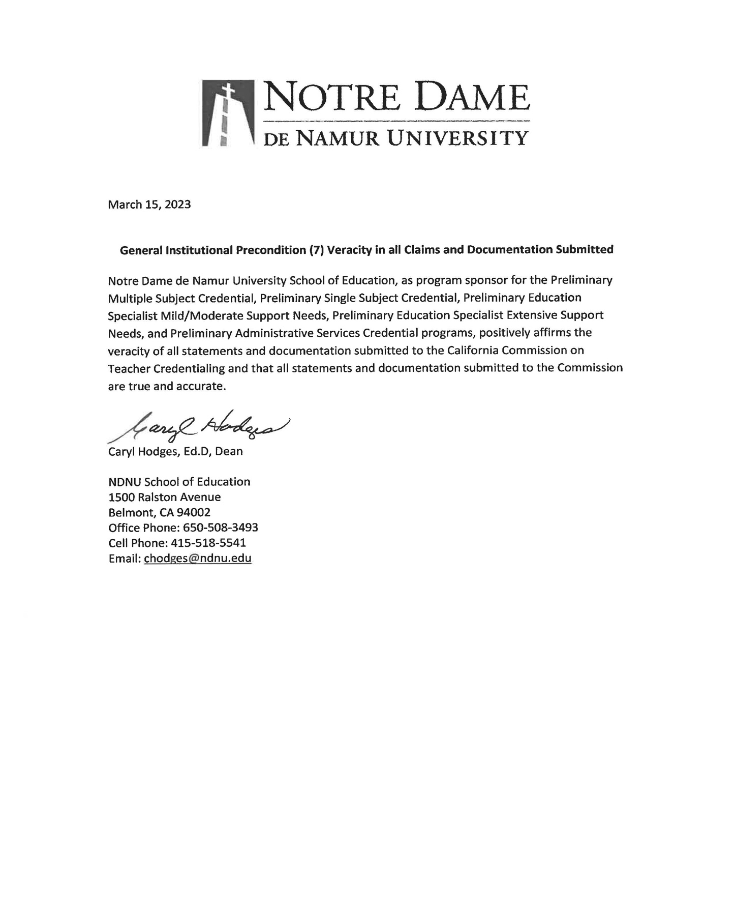

Assurances Letter

