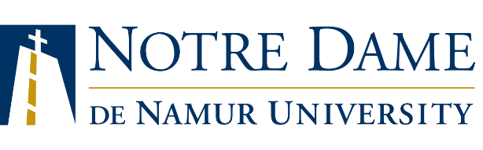
Founded in 1851, Notre Dame de Namur University (NDNU) is a dynamic institution whose reputation for excellence and commitment to the development of the whole person comes from its heritage as a Catholic institution founded by the Sisters of Notre Dame de Namur. Our faculty is committed to carrying out these core values throughout the curriculum.
NDNU is a fully accredited master’s university. The campus is located 25 miles south of San Francisco, neighboring Silicon Valley. NDNU serves a diverse student body from a wide variety of backgrounds and experiences and actively commits itself to educational accessibility for all students. Candidates from all backgrounds and especially from underrepresented groups are encouraged to apply.

Job Title:
Reports To:
Status:
Work Location:
Salary:
Position Summary

Key Responsibilities
- XXXX
- XXXX
- XXXX

Qualifications

Working Conditions

Application Procedures
NDNU is committed to providing an educational environment that supports a diverse student population. In your cover letter, please include information about your experiences in working in a diverse environment, and what qualities you would bring to support this commitment to inclusive excellence at NDNU.

EEOC Statement
Notre Dame de Namur University is an equal opportunity employer firmly committed to non-discrimination in its hiring and other employment practices and personnel policies. In compliance with all applicable federal and state laws, except where a bona fide occupational qualification exists, NDNU will make employment decisions irrespective of the staff member’s race, color, religion, religious creed, ancestry, national origin, age (except for minors), sex, marital status, citizenship status, military service status, sexual orientation, medical condition (a cancer-related or genetic condition), disability and/or any another status protected by law.

